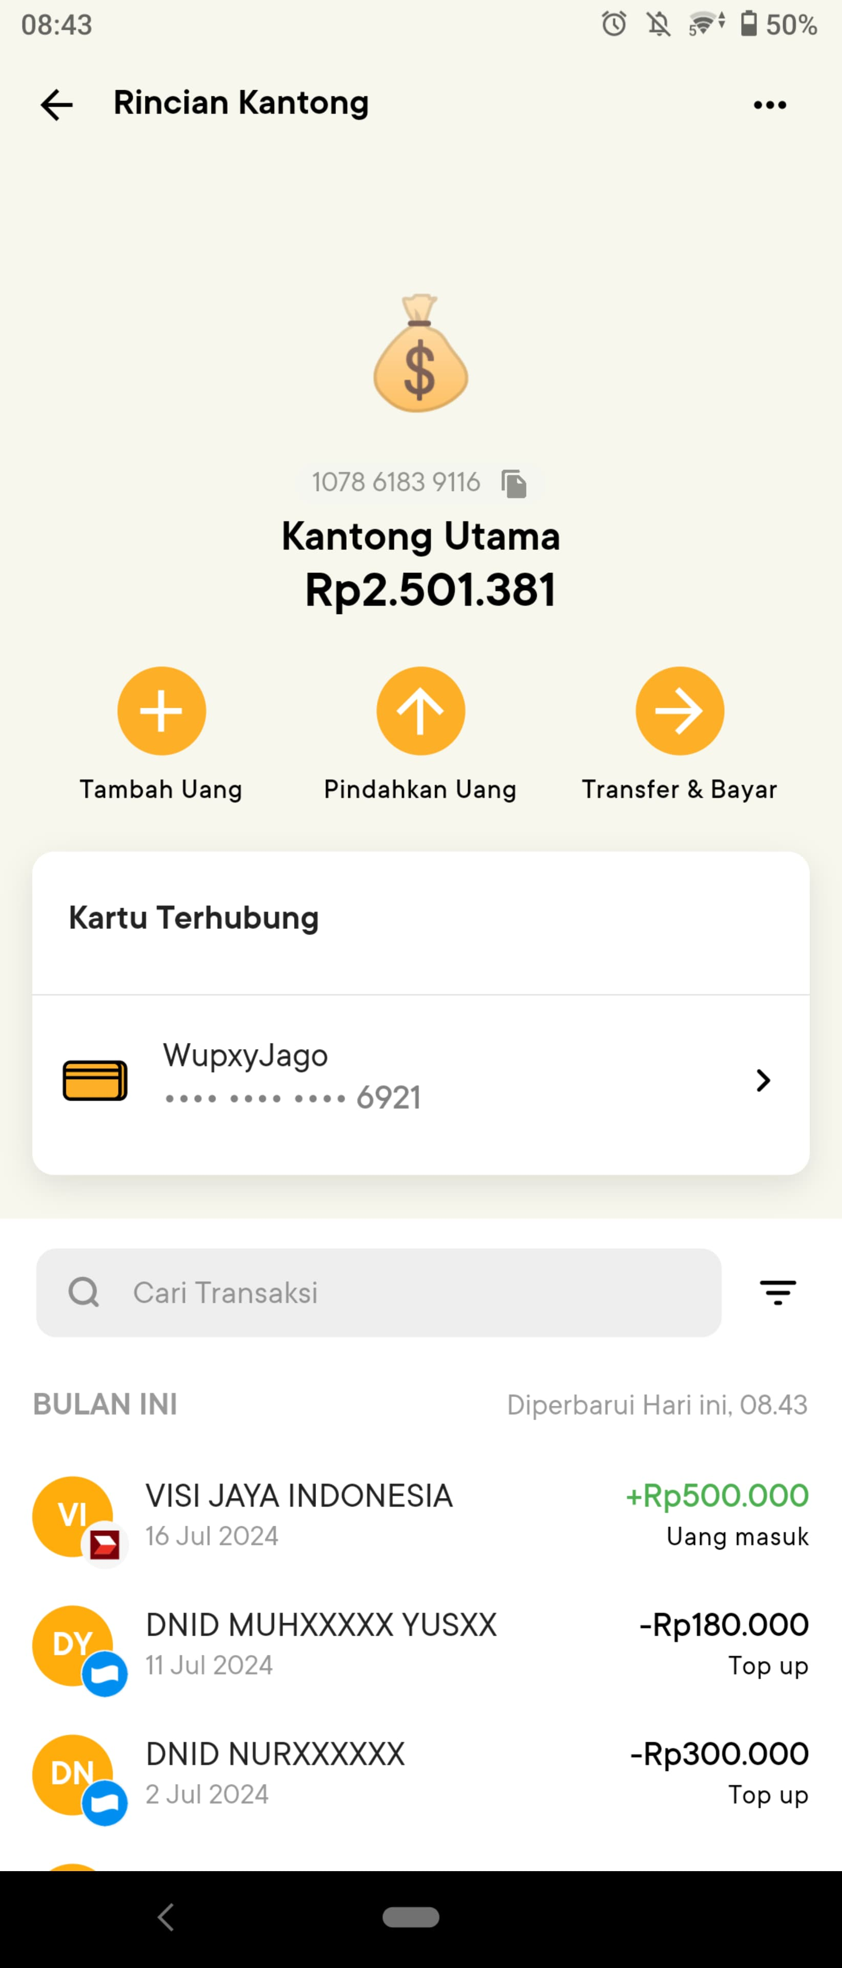**Sreenshoot Bank Jago**